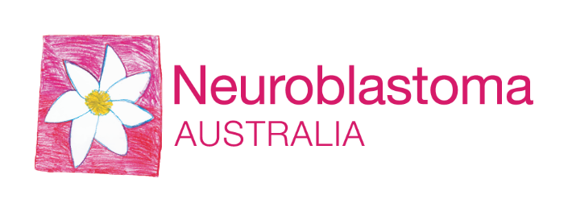
Copy to copy/paste for your email
I’m making a difference and running for a cause that is close to my heart, raising funds for research into neuroblastoma childhood cancer. Please support my efforts by making a secure online donation and commenting on my fundraiser page here. <insert fundraiser page link>
Donations through this platform are secure and will be remitted directly through to my charity of choice, Neuroblastoma Australia.
This year, I will be running <insert distance> at Run2Cure. My motivation for joining this fun run is <insert motivation>
For those not familiar with this devastating cancer, I’ve included some information below.
What is neuroblastoma?
Neuroblastoma is the #1 cause of cancer deaths in under 5’s. Approximately 40 children a year are diagnosed with this cruel cancer, yet for aggressive neuroblastoma there is still only a 50% survival rate. Childhood cancer research only receives a mere 10% of all government cancer research funding, meaning funding falls to the community to provide the means for scientists and research institutes to find better, kinder and more effective treatments for children diagnosed.
Where will your donations go?
All my donations will be going to the charity Neuroblastoma Australia. This charity funds more research that will improve the quality of life of the children and families diagnosed with neuroblastoma. For more information on the current research projects, they are funding, please click here.
Thank you for your support. If you would like to join me in the run, please visit run2cure.org.au to sign up today.

