Register today for the Run2Cure 2019 School Challenge
Registering has never been easier! When you visit www.run2cure.org.au and click any ‘Register to run’ button, you will be taken to our new registration page powered by Race Roster.
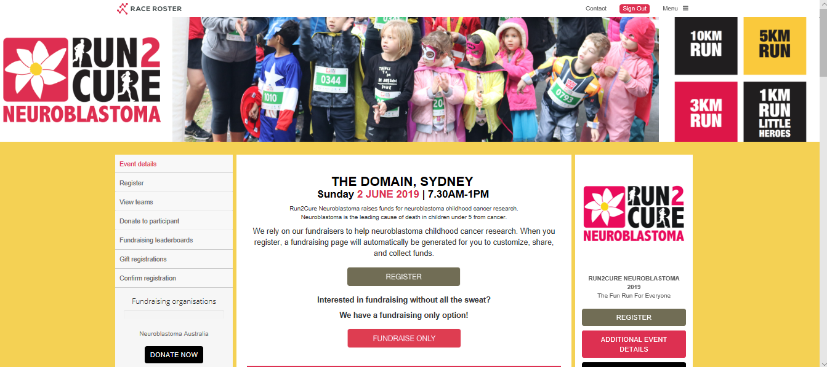

Simply follow the prompts to register and if you run into any trouble please contact our friendly team on: support@raceroster.com

Register your child for the School Challenge
Click register to open the registration page.

Runs
Pick the 3K and choose the relevant age group for your child.
Note: you can also register yourself for the School Challenge (just click the 3K Adults group) in fact, we would recommend that at least one adult registers for every ten children.
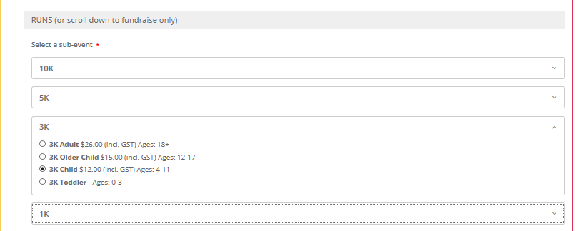

Personal information
Register your child by clicking ‘Someone else’
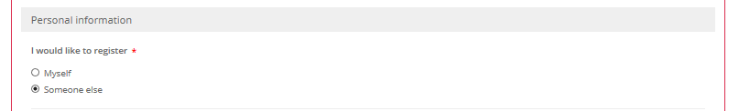

Teams
To join your school’s team click ‘Yes, add this registrant to a team created by someone else’ then you will be asked to ‘Select team’.
Scroll down the lists of schools to find yours.
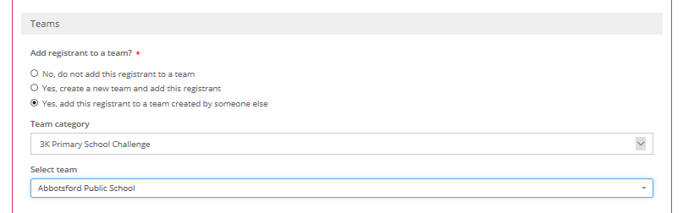

If your school isn’t listed – be the first!
If your school name isn’t listed as a team, simply click ‘Yes, create a new team and add this registrant’ and type in your school’s full title under ‘Team name’.
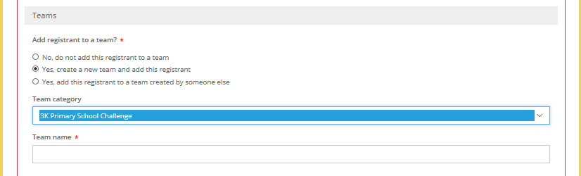

Get your 10% discount!
All School Challenge registrations come with a 10% discount.
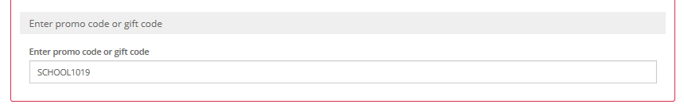
Simply enter code SCHOOL1019 as a promo code.

Fundraising pages
Run2Cure Neuroblastoma raises funds for vital research into a cure for the children’s cancer neuroblastoma. This is the leading cause of death in children under five from cancer.
We need your help.
When you register for Run2Cure a fundraising page will automatically be set up for you and if you choose the school team, you will be added to that fundraising page also.
Add an image, write a message, share with family and friends. Raising even a small amount will still help support scientists find better, kinder treatments for this devastating cancer.
If you have multiple pages set up and would like to choose one dedicated fundraising page, our team can manually delete fundraising pages. Simply email support@raceroster.com with your details.
Thank you for your support
Thank you for making a difference and helping us get one step closer to a world where all children diagnosed with neuroblastoma get to live healthy lives, free from side effects of their treatment.

