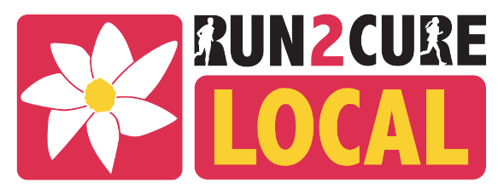

RUN2CURE LOCAL TERMS & CONDITIONS
By registering to take part in Run2Cure Local 2022, I agree to the following terms and conditions:
1. Registration:
I understand that I am required to complete the registration form. I declare that all information provided on the registration form is true and correct.
2. Safety and Wellbeing:
I declare that I am 18 years or older on event day or that if I am the parent/legal guardian of a participant who is under the age of 18 years, I will be responsible for their safety and well-being.
- I understand I am responsible for organising my own walk or run and if I am organising a team, I will advise them of any risks. I am also responsible for organising insurance if required.
- I will adhere to all current guidelines provided by my relevant state regarding COVID-19 safety
- If I am a team leader or registering multiple people, I certify that I have made all persons in my team aware of these terms and conditions, and that agreeing with them themselves, they have authorised me to register on their behalf.
- I understand the event organisers reserve the right to delay, postpone or cancel the event for reasons outside of the event organisers control.
- I accept that Neuroblastoma Australia will not accept any loss or damage of personal items or data or be held accountable for any injury.
- I agree to conduct myself in a professional and courteous manner during participation in the event
3. Risk
- Entrants participate in the Event entirely at his or her own risk.
- Entrants will take all reasonable measures to protect him or herself from the risks of participation.
- Entrants accept all responsibility for travel and medical insurance and for payment and/or reimbursement of medical/surgical expenses incurred on his or her behalf.
- Entrants acknowledge that the Event involves the real risk of serious injury or risk of death, from various causes including over-exertion, dehydration, accidents with other competitors, spectators and road users and weather conditions, just to name a few. Each Entrant (or his or her parent or legal guardian) has voluntarily read and understood this warning and accept the inherent risks of the Event.
- To the best of each Entrant’s knowledge, he or she is not suffering from a condition, which would preventand/or render them unfit to participate in the Event. Each Entrant recognises the difficulties of participating in the Event and attests that he or she is physically fit to compete safely, have trained sufficiently and have not been advised by a qualified medical practitioner not to compete in the Event.

